**Experiment 3**

**Design of Google Logo using GIMP.**

Step 1:- Select File menu, click on New option. Set the width and height and then click on OK button. Fill this new image with White color

Step 2:- Select Image menu, click on Guides option and then select New Guide(By percent) and set the direction Horizontal. Then click on OK button. Follow the same process again to set the direction Vertical.

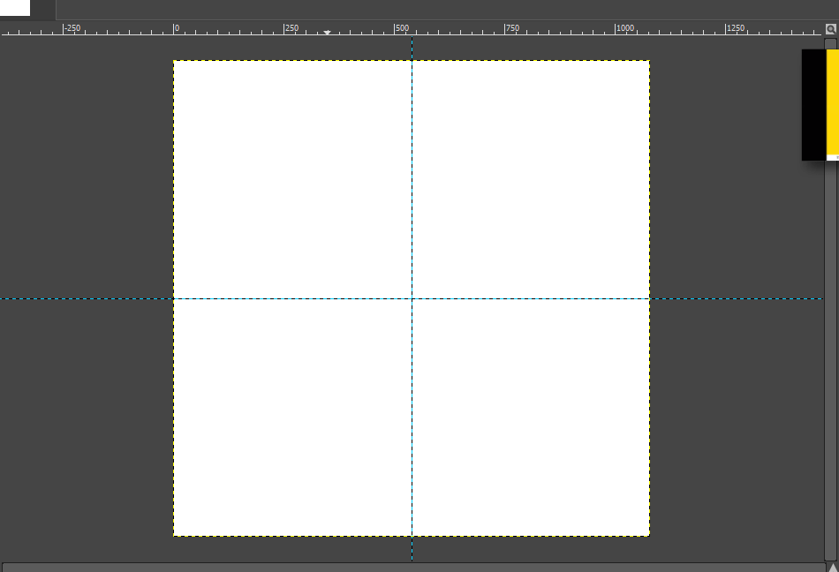

Step 3:- Now select ellipse select tool. Press Ctrl+Shift and draw using ellipse selection tool with ratio of your image.

Step 4:- Select add text tool and write the tag line which you want to show in our logo.

Step 5:- Wrap the text around the circle using text along path feature.

Step 5:-Now in the paths section , select your text along path and right click over it and then select Fill path option. Select on OK button

Step6:- Add the image of google in our logo by selecting the image using ellipse tool.

Step 7:- Now hide all the paths and selections, just show the your filled text path and your google logo.

Step 8:- At last our logo is ready.



I created a logo using similar process:

